MATLAB Code Explanation:
Initial setup gives a clear console, clears all the preset values of variables and closes all the figures.

% Initial Setup
clear; clc; close all;

A random pulse has to be generated to visualize an ideal working of the algorithm.
The pulse of signal is designed to be of the length of 64 bauds and the pulse is names theta. All the bauds would hold the value between 0 and 1 as double [8 byte] floating point values. The signal pulse generates a complex double of theta with real and imaginary components.

% Create pulse to detect

rng('default');%random variable will be selected using default algorithm
PulseLen = 64;%64 bits will be the length of the pulse
theta = rand(PulseLen,1);%an array is generated with size 64x1 of values 0 to 1
pulse = exp(1i*2*pi*theta);%the values are converted into complex form

The total length of the pulse to be transmitted is of 5000 bauds which consists of the actual 64 bauds peak of the pulse. The PulseLoc variable is randomly generated to add the peak to the generated location. The entire array of TxSignal is given the value zero upon which the pulse signal is overlaid.
% Insert pulse to Tx signal

rng('shuffle');%random variable will be selected using default algorithm
TxLen = 5000;%total transmition length will be 5000 bits
PulseLoc = randi(TxLen-PulseLen*2);% defining where to insert the pulse

TxSignal = zeros(TxLen,1);% the rest 5000-64 = 4936 bits should be zero while transmitting
TxSignal(PulseLoc:PulseLoc+PulseLen1) = pulse; %merging both pulse to
5000 bits chain

Generated TxSignal: (the peak attained in this diagram is subjected to change for every run).
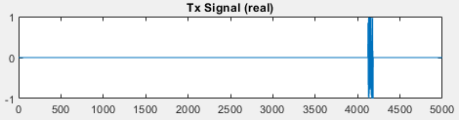

The TxSignal attained so far is the signal that is required at the receiver end but to mimic the actual transmission of the signal AWGN is added to the signal and will be given a name RxSignal.
Noise signal holds a value random complex numbers which would be added onto the TxSignal. The RxSignal is scaled to fit the entire range between [-1, 1].
% Create Rx signal by adding noise

Noise = complex(randn(TxLen,1),randn(TxLen,1));%random complex numbers
RxSignal = TxSignal + Noise; % addding noise to signal

% Scale Rx signal to +/- one

scale1 = max([abs(real(RxSignal)); abs(imag(RxSignal))]); %converting it for convinience
RxSignal = RxSignal/scale1;%dividing it by max value of signal

Generated RxSignal :
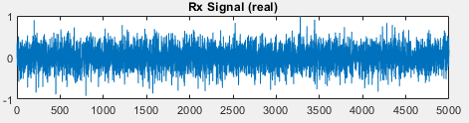
A Correlation filter is used to retrieve back the algorithm. Where the conjugate of the inversed pulse is provided as CorrFilter signal. The task is to find the position of the pulse. The FilterOut Signal correlates the RxSignal against the matched filter to find the location of the signal, which also finds the peak value of the pulse.
% Create matched filter coefficients

CorrFilter = conj(flip(pulse))/PulseLen;%step 1 of corelation filter

% Correlate Rx signal against matched filter

FilterOut = filter(CorrFilter,1,RxSignal);%step 2 of corelation filter

% Find peak magnitude & location

[peak, location] = max(abs(FilterOut));%getting the value of peak at filter
output

The output after the filter.

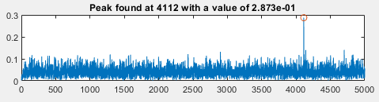

The following commands are used to print the values and the graphs in the output screen.
% Print results
figure(1)%creating a figure
subplot(311); plot(real(TxSignal)); title('Tx Signal (real)');%the signal without noise
subplot(312); plot(real(RxSignal)); title('Rx Signal (real)');%the signal with noise

t = 1:length(FilterOut);%length of signal
str = sprintf('Peak found at %d with a value of %.3d',location,peak);%print the value of peak
subplot(313); plot(t,abs(FilterOut),location,peak,'o'); title(str);%the filtered signal

The above used code is used as the golden reference to stimulate the same using a hardware friendly model using simulink.
Measuring 5000 bauds can be done with ease by compiler at Matlab but to make it hardware applicable a window method is used where, a window of 11 bauds will be taken at a time and the middle baud (the 6th one) is checked to exceed the threshold value.
% Implementing the same above mentioned algorithm in a hardware friendly manner.

WindowLen = 11;%comparing the 5000 bits with 11 bits at a time serially
MidIdx = ceil(WindowLen/2);%gets the value of 6th bit in the series
threshold = 0.03;%only the peak would be more than this value.

%note: for convenience the threshold value was adjusted from experimental
%trial and error method

Attaining a square root of a complex variable could increase the complexity of the circuit, hence MagSqOut signal is used such that the absolute value of the signal is squared hence making calculations easier.
% Compute magnitude squared to avoid sqrt operation
MagSqOut = abs(FilterOut).^2;

The Window of 5000 bauds is let to slide comparing the threshold value at each iteration. The MidSample and CompareOut confirms that the middle value satisfies the conditions only at the start of the actual pulse.
% Sliding window operation
for n = 1:length(FilterOut)-WindowLen %1 to 4989

% Compare each value in the window to the middle sample via subtraction
DataBuff = MagSqOut(n:n+WindowLen-1);%stream of 11 bits
MidSample = DataBuff(MidIdx);%bit 6 of the sample
CompareOut = DataBuff - MidSample; % this is a vector

% if all values in the result are negative and the middle sample is
% greater than a threshold, it is a local max
if all(CompareOut <= 0) && (MidSample > threshold)
peak_2 = MidSample;
location_2 = n + (MidIdx-1);%gives the peak location
end
end

A fixed point is much feasible to use in a hardware model than a floating point. Hence tools from Fixed point designer toolbox is used to convert the values into fixed point sacrificing precision for bandwidth.
% Simulate model in fixed-point or floating-point
fxpt_mode = true;
if fxpt_mode % fixed-point
DT_input = fixdt(1,16,14);%fixdt(signed/unsigned',wordlength,fractionlength)
DT_filter = fixdt(1,18,15);
DT_power = fixdt(1,18,11);
else % floating-point
DT_input = 'double';%64 bit floating point
DT_filter = 'double';
DT_power = 'double';
end
DT_coeff = fixdt(1,18); % coeff is treated as double if input is double

Converting column vector to row.
if iscolumn(CorrFilter)
CorrFilter = transpose(CorrFilter); % need row vector for filter block
end

SimTime fixes the time for which the model will run. And slout instantiate the project.
%stimulation time to be length of the signal plus 30 time units
%30 time units= 10 in front end + 10 in back end + 10 buffer
SimTime = length(RxSignal) + WindowLen + 30;

% Simulate model
slout = sim('project_detect');
Two functions have been instantiated which will be called multiple times during simulation.
% Correlation filter output
FilterOutSL = getLogged(slout,'filter_out');
FilterValid = getLogged(slout,'filter_valid');
FilterOutSL = FilterOutSL(FilterValid);%signal through filter

%to compare and print logged signal values
compareData(real(FilterOut),real(FilterOutSL),{2 3 1},'ML vs SL correlator output (re)');
compareData(imag(FilterOut),imag(FilterOutSL),{2 3 2},'ML vs SL correlator output (im)');

% Magnitude squared output
MagSqSL = getLogged(slout,'mag_sq_out');
MagSqSL = MagSqSL(FilterValid);%magnitude square of filter

%to comapare and print logged signal values
compareData(MagSqOut,MagSqSL,{2 3 3},'ML vs SL mag-squared output');

% Peak value
MidSampleSL = getLogged(slout,'mid_sample');
Detected = getLogged(slout,'detected');
PeakSL = double(MidSampleSL(Detected>0));

The output of the code is displayed in the figure using print commands.
fprintf('\nPeak location = %d, magnitude = %.3d using global max\n',location,peak);
fprintf('Peak location = %d, mag-squared = %.3d using local max\n',location_2,peak_2);
fprintf('Peak mag-squared from Simulink = %.3d, error = %.3d\n',PeakSL,abs(peak_2-PeakSL));

Output:
- The red legend in the output is the measure of deviation of the simulink model’s output to that of the Matlab’s golden reference, which stays at zero indicating perfect working of the hardware model.
- Yellow legend is hidden in the graph as the blue legend overlaps the reference plot.
- The error is in terms of 10⁻⁶ is caused due to the fixed point conversion, which could be neglected.
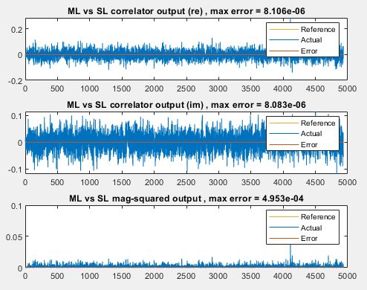

Command Window Output:
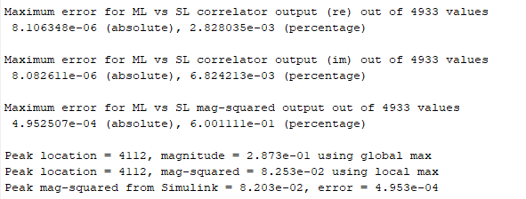

The two functions used in the above programs:

1. Getlogged:
Squeeze removes a dimension form the array. This function is used to log all the values in the simulink model.
Empty signal is also eliminated and it triggers an error while that happens. logsout, getElement are key triggers used to transfer the signal for one sub block to other.
%%Defining the functions used in the code above

%getLogged function
function signal_val = getLogged(simout_obj,signal_name)%function instantiation

logsout = simout_obj.logsout;%load logged signal

%checking for possible error in outputs
if isempty(logsout)
error('No logged signal found. Make sure ''%s'' is logged in the model',...
signal_name);
end

sig = logsout.getElement(signal_name);%read elements of logged signal

%checking for possible error in outputs
if isempty(sig)
error('Signal ''%s'' not found. Make sure it is logged and named correctly.',...
signal_name);
end

signal_val = squeeze(sig.Values.Data);
%squeeze returns an array with the same elements as the input,...
%but with dimensions of length 1 removed.

end

2. Compare data:
This function doesn’t affect the hardware model but is used to find the differences between both, hence would help us solve the bugs.
%compareData function
%function instantiation
function err_vec = compareData(reference,actual,figure_number,textstring)

% Vector input only
if ~isvector(reference) || ~isvector(actual)
error('Input signals must be vector');%check for inputs to be vector
else
if isrow(reference)
reference = transpose(reference);%convert to column vector
end
if isrow(actual)
actual = transpose(actual);%convert to column vector
end
end

% Make signals same length if necessary
if length(reference) ~= length(actual)
% warning(['Length of reference (%d) is not the same as actual signal (%d).'...
% ' Truncating the longer input.'],length(reference),length(actual));

%balance length of both the vectors to be equal
len = 1:min(length(reference),length(actual));
reference = reference(len);%length modification of reference
actual = actual(len);%length modification of actual
end

% Turn complex into vector
if xor(isreal(reference),isreal(actual))%checking for nature of both signals
error('Input signals are not both real or both complex');
elseif ~isreal(reference)
ref_vec = double([real(reference) imag(reference)]);%covert to double
act_vec = double([real(actual) imag(actual)]);%covert to double
tag = {'(Real)','(Imag)'};
else
ref_vec = double(reference);%covert to double
act_vec = double(actual);%covert to double
tag = {''};
end

% Configure figure
if iscell(figure_number)
if size(ref_vec,2) > 1 % complex
error('Cannot yet subplot multiple complex inputs');
else
figure(figure_number{1})%defines figure(2)
end
else
figure(figure_number)
end
c = get(groot,'defaultAxesColorOrder');%used at plotting

% Compute error
err_vec = ref_vec - act_vec;%error vector to be printed on output
max_err = max(abs(err_vec));%max error to be printed on output
max_ref = max(abs(ref_vec));%max reference to be printed on output

The calculated output is sent back to the main screen using print commands.
%output printed on command window
fprintf('\nMaximum error for %s out of %d values\n',textstring,length(actual));

for n = 1:size(ref_vec,2)

%output printed on Command window
fprintf('%s %d (absolute), %d (percentage)\n',tag{n},max_err(n),max_err(n)/max_ref(n)*100);

if iscell(figure_number)
total_plot = figure_number{2};% equal to 3
plot_num = figure_number{3};%figure number can be 1 to 3

else
total_plot = size(ref_vec,2);
plot_num = n;
end

subplot(total_plot,1,plot_num)%subplot generation

plot(ref_vec(:,n),'Color',c(3,:));%uses 1st color for reference

hold on %plots 3 graphs over the same plot

plot(act_vec(:,n),'Color',c(1,:));%uses 2nd color for actual
plot(err_vec(:,n),'Color',c(2,:));%uses 3rd color for error

legend('Reference','Actual','Error')%defining legend
hold off

title(sprintf('%s %s, max error = %.3d',textstring,tag{n},max_err(n)));%title
end
end

Command prompt output:
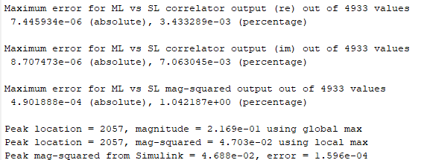

Simulink model:

Top model:
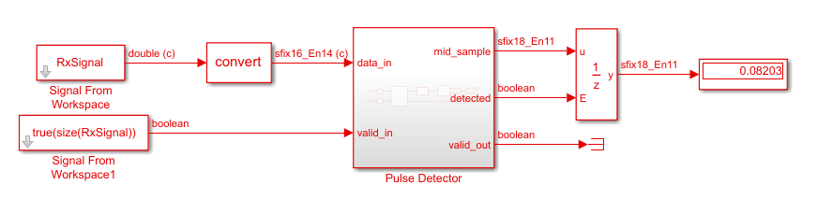
The RxSignal is given in parallel to valid in signal to trigger the incoming of received signal. The convert block converts the double precision floating point value to fixed point value. The output is displayed in the output block which is controlled by a unit delay block to avoid glitches.

Pulse Detector Top module:
This block will be the main module in the synthesis of RTL and other sub blocks will be instantiated from this top module.

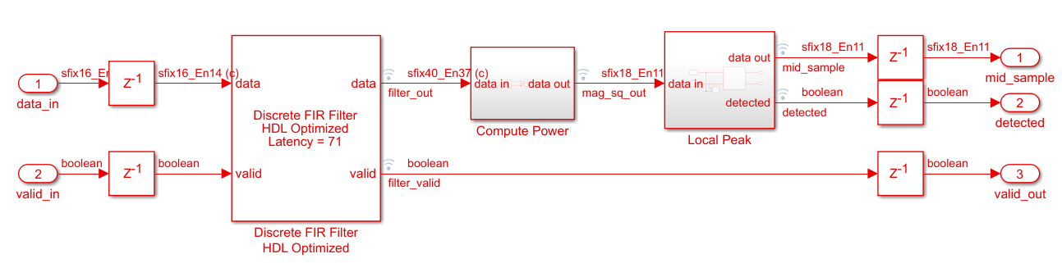
The signal is fed into the discrete FIR filter which then sends out the filter out signal. The filter_out signal is logged into Compute power sub block.
Compute Power sub module:
The incoming fixed point value is converted into less precision value of the same and is squared in a hardware friendly manner. The result is then logged to the next sub block.
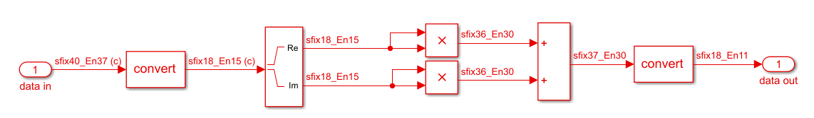

Local Peak sub module:
11 values are collected using the delay block which is connected to same DT block which checks if the connected inputs are of same data type. If not it forces all the input to be of same type.
The fcn block holds a matlab code, which checks for the peak, if detected will send out the data in data out port and sets the detected signal to be high. If not the window is updated to receive the next bit contnuing till detection of the peak.
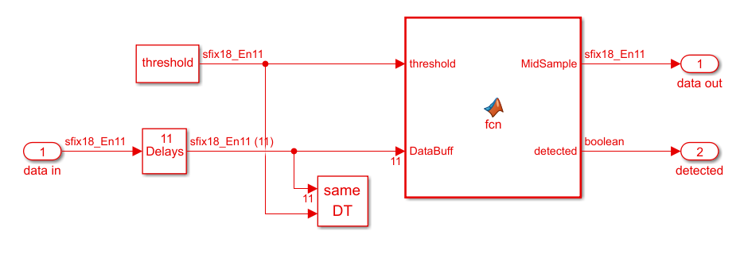
fcn code:

% Hardware friendly implementation of peak finder
%
% Function inputs:
% * WindowLen - non-tunable parameter defined under Simulink->Edit Data
% * threhold - input port (connected to constant)
% * DataBuff - input port (buffering done using Simulink block)
%
% Function outputs:
% * "detected" is set when MidSample is local max

function [MidSample,detected] = fcn(threshold, DataBuff, WindowLen)
%#codegen

MidIdx = ceil(WindowLen/2);

% Compare each value in the window to the middle sample via subtraction
MidSample = DataBuff(MidIdx);
CompareOut = DataBuff - MidSample; % this is a vector

% if all values in the result are negative and the middle sample is
% greater than a threshold, it is a local max
if all(CompareOut <= 0) && (MidSample > threshold)
detected = true;
else
detected = false;
end

This mimics the part of window code in Matlab but has few keywords converted to hardware friendly Boolean terms such as true and false.

HDL Coder:
The DUT compatibility is checked using HDL coder, checker not only ensures the blocks used in the subsystem is real compatible but also ensures the settings, ports and configurations of these blocks do not generate inefficient hardware. The HDL model checker includes options for native floating-point and industry standard checks.

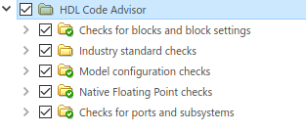
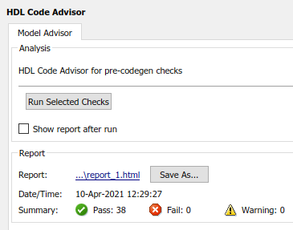

Once the checks are successful, the HDL workflow advisor has to be run to initiate generation of HDL code. After generation of HDL code, Quartus prime is used to visualize the resources and RTL design.

RTL Design of modules:

Pulse Detector module:
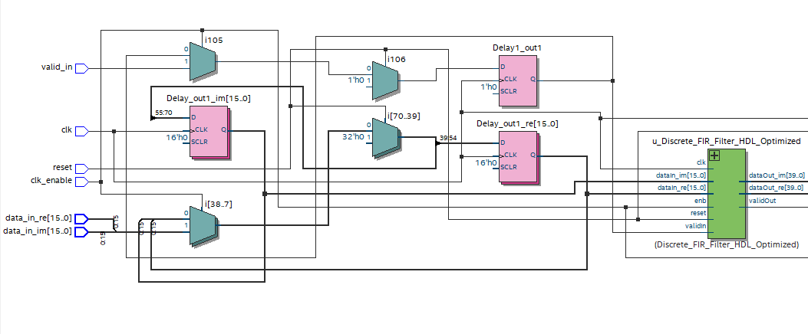
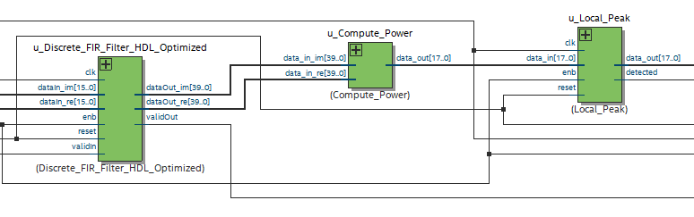
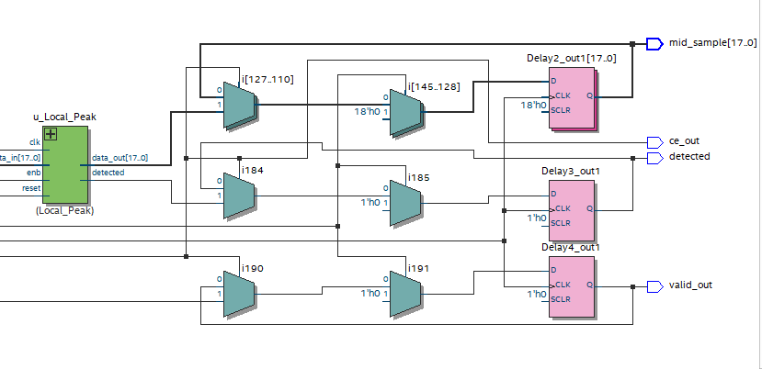
FIR filter sub module:

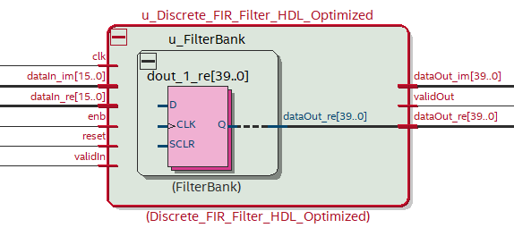

Compute Power sub module:

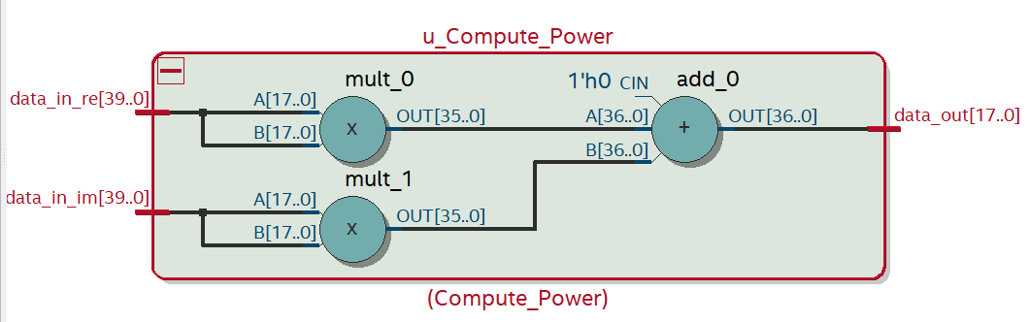

Local peak sub module:

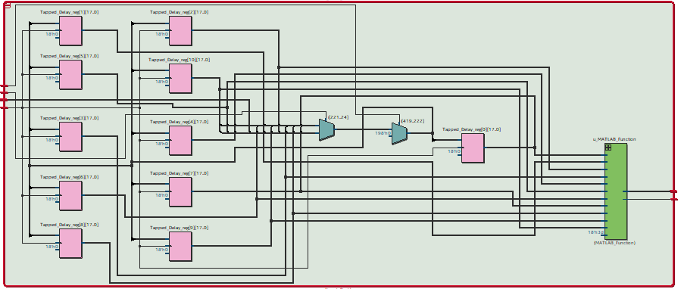

Matlab function sub module:

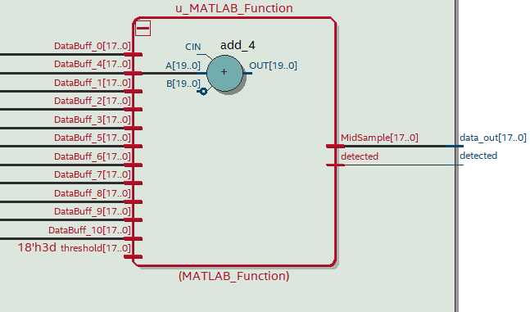

Modules hierarchy and resource utilization:

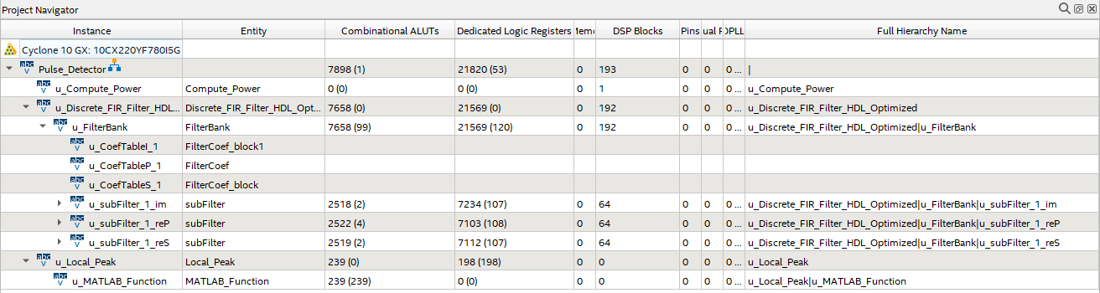

Verilog codes:

Pulse detector:

`timescale 1 ns / 1 ns

module Pulse_Detector
(clk,
reset,
clk_enable,
data_in_re,
data_in_im,
valid_in,
ce_out,
mid_sample,
detected,
valid_out);

input clk;
input reset;
input clk_enable;
input signed [15:0] data_in_re; // sfix16_En14
input signed [15:0] data_in_im; // sfix16_En14
input valid_in;
output ce_out;
output signed [17:0] mid_sample; // sfix18_En11
output detected;
output valid_out;

wire enb;
reg signed [15:0] Delay_out1_re; // sfix16_En14
reg signed [15:0] Delay_out1_im; // sfix16_En14
reg Delay1_out1;
wire signed [39:0] filter_out_re; // sfix40_En37
wire signed [39:0] filter_out_im; // sfix40_En37
wire filter_valid;
wire signed [17:0] mag_sq_out; // sfix18_En11
wire signed [17:0] mid_sample_1; // sfix18_En11
wire detected_1;
reg signed [17:0] Delay2_out1; // sfix18_En11
reg Delay3_out1;
reg Delay4_out1;

assign enb = clk_enable;

always @(posedge clk)
begin : Delay_process
if (reset == 1'b1) begin
Delay_out1_re <= 16'sb0000000000000000;
Delay_out1_im <= 16'sb0000000000000000;
end
else begin
if (enb) begin
Delay_out1_re <= data_in_re;
Delay_out1_im <= data_in_im;
end
end
end

always @(posedge clk)
begin : Delay1_process
if (reset == 1'b1) begin
Delay1_out1 <= 1'b0;
end
else begin
if (enb) begin
Delay1_out1 <= valid_in;
end
end
end

Discrete_FIR_Filter_HDL_Optimized u_Discrete_FIR_Filter_HDL_Optimized (.clk(clk),
.reset(reset),
.enb(clk_enable),
.dataIn_re(Delay_out1_re), // sfix16_En14
.dataIn_im(Delay_out1_im), // sfix16_En14
.validIn(Delay1_out1),
.dataOut_re(filter_out_re), // sfix40_En37
.dataOut_im(filter_out_im), // sfix40_En37
.validOut(filter_valid)
);

Compute_Power u_Compute_Power (.data_in_re(filter_out_re), // sfix40_En37
.data_in_im(filter_out_im), // sfix40_En37
.data_out(mag_sq_out) // sfix18_En11
);

Local_Peak u_Local_Peak (.clk(clk),
.reset(reset),
.enb(clk_enable),
.data_in(mag_sq_out), // sfix18_En11
.data_out(mid_sample_1), // sfix18_En11
.detected(detected_1)
);

always @(posedge clk)
begin : Delay2_process
if (reset == 1'b1) begin
Delay2_out1 <= 18'sb000000000000000000;
end
else begin
if (enb) begin
Delay2_out1 <= mid_sample_1;
end
end
end

assign mid_sample = Delay2_out1;

always @(posedge clk)
begin : Delay3_process
if (reset == 1'b1) begin
Delay3_out1 <= 1'b0;
end
else begin
if (enb) begin
Delay3_out1 <= detected_1;
end
end
end

assign detected = Delay3_out1;

always @(posedge clk)
begin : Delay4_process
if (reset == 1'b1) begin
Delay4_out1 <= 1'b0;
end
else begin
if (enb) begin
Delay4_out1 <= filter_valid;
end
end
end

assign valid_out = Delay4_out1;

assign ce_out = clk_enable;

endmodule // Pulse_Detector

FIR filter:

`timescale 1 ns / 1 ns

module Discrete_FIR_Filter_HDL_Optimized
(clk,
reset,
enb,
dataIn_re,
dataIn_im,
validIn,
dataOut_re,
dataOut_im,
validOut);

input clk;
input reset;
input enb;
input signed [15:0] dataIn_re; // sfix16_En14
input signed [15:0] dataIn_im; // sfix16_En14
input validIn;
output signed [39:0] dataOut_re; // sfix40_En37
output signed [39:0] dataOut_im; // sfix40_En37
output validOut;

FilterBank u_FilterBank (.clk(clk),
.reset(reset),
.enb(enb),
.dataIn_re(dataIn_re), // sfix16_En14
.dataIn_im(dataIn_im), // sfix16_En14
.validIn(validIn),
.dataOut_re(dataOut_re), // sfix40_En37
.dataOut_im(dataOut_im), // sfix40_En37
.validOut(validOut)
);

endmodule // Discrete_FIR_Filter_HDL_Optimized

The submodule Filterbank used is attached in the https://github.com/raja-aadhithan/RTL-design-for-MATLAB-model/tree/main/verilog_syntesis page, which consists of further submodules namely : subFilter, FilterCoef_block, FilterCoef_block1.

Compute power:

`timescale 1 ns / 1 ns

module Compute_Power
(data_in_re,
data_in_im,
data_out);

input signed [39:0] data_in_re; // sfix40_En37
input signed [39:0] data_in_im; // sfix40_En37
output signed [17:0] data_out; // sfix18_En11

wire signed [17:0] Data_Type_Conversion1_out1_re; // sfix18_En15
wire signed [17:0] Data_Type_Conversion1_out1_im; // sfix18_En15
wire signed [35:0] Product_out1; // sfix36_En30
wire signed [35:0] Product1_out1; // sfix36_En30
wire signed [36:0] Add_add_cast; // sfix37_En30
wire signed [36:0] Add_add_cast_1; // sfix37_En30
wire signed [36:0] Add_out1; // sfix37_En30
wire signed [17:0] Data_Type_Conversion_out1; // sfix18_En11

assign Data_Type_Conversion1_out1_re = data_in_re[39:22];
assign Data_Type_Conversion1_out1_im = data_in_im[39:22];

assign Product_out1 = Data_Type_Conversion1_out1_re * Data_Type_Conversion1_out1_re;

assign Product1_out1 = Data_Type_Conversion1_out1_im * Data_Type_Conversion1_out1_im;

assign Add_add_cast = {Product_out1[35], Product_out1};
assign Add_add_cast_1 = {Product1_out1[35], Product1_out1};
assign Add_out1 = Add_add_cast + Add_add_cast_1;

assign Data_Type_Conversion_out1 = Add_out1[36:19];

assign data_out = Data_Type_Conversion_out1;

endmodule // Compute_Power

Local Peak:

`timescale 1 ns / 1 ns

module Local_Peak
(clk,
reset,
enb,
data_in,
data_out,
detected);

input clk;
input reset;
input enb;
input signed [17:0] data_in; // sfix18_En11
output signed [17:0] data_out; // sfix18_En11
output detected;

wire signed [17:0] Constant_out1; // sfix18_En11
reg signed [17:0] Tapped_Delay_reg [0:10]; // sfix18 [11]
wire signed [17:0] Tapped_Delay_reg_next [0:10]; // sfix18_En11 [11]
wire signed [17:0] Tapped_Delay_out1 [0:10]; // sfix18_En11 [11]
wire signed [17:0] MidSample; // sfix18_En11

assign Constant_out1 = 18'sb000000000000111101;

always @(posedge clk)
begin : Tapped_Delay_process
if (reset == 1'b1) begin
Tapped_Delay_reg[0] <= 18'sb000000000000000000;
Tapped_Delay_reg[1] <= 18'sb000000000000000000;
Tapped_Delay_reg[2] <= 18'sb000000000000000000;
Tapped_Delay_reg[3] <= 18'sb000000000000000000;
Tapped_Delay_reg[4] <= 18'sb000000000000000000;
Tapped_Delay_reg[5] <= 18'sb000000000000000000;
Tapped_Delay_reg[6] <= 18'sb000000000000000000;
Tapped_Delay_reg[7] <= 18'sb000000000000000000;
Tapped_Delay_reg[8] <= 18'sb000000000000000000;
Tapped_Delay_reg[9] <= 18'sb000000000000000000;
Tapped_Delay_reg[10] <= 18'sb000000000000000000;
end
else begin
if (enb) begin
Tapped_Delay_reg[0] <= Tapped_Delay_reg_next[0];
Tapped_Delay_reg[1] <= Tapped_Delay_reg_next[1];
Tapped_Delay_reg[2] <= Tapped_Delay_reg_next[2];
Tapped_Delay_reg[3] <= Tapped_Delay_reg_next[3];
Tapped_Delay_reg[4] <= Tapped_Delay_reg_next[4];
Tapped_Delay_reg[5] <= Tapped_Delay_reg_next[5];
Tapped_Delay_reg[6] <= Tapped_Delay_reg_next[6];
Tapped_Delay_reg[7] <= Tapped_Delay_reg_next[7];
Tapped_Delay_reg[8] <= Tapped_Delay_reg_next[8];
Tapped_Delay_reg[9] <= Tapped_Delay_reg_next[9];
Tapped_Delay_reg[10] <= Tapped_Delay_reg_next[10];
end
end
end

assign Tapped_Delay_out1[0] = Tapped_Delay_reg[0];
assign Tapped_Delay_out1[1] = Tapped_Delay_reg[1];
assign Tapped_Delay_out1[2] = Tapped_Delay_reg[2];
assign Tapped_Delay_out1[3] = Tapped_Delay_reg[3];
assign Tapped_Delay_out1[4] = Tapped_Delay_reg[4];
assign Tapped_Delay_out1[5] = Tapped_Delay_reg[5];
assign Tapped_Delay_out1[6] = Tapped_Delay_reg[6];
assign Tapped_Delay_out1[7] = Tapped_Delay_reg[7];
assign Tapped_Delay_out1[8] = Tapped_Delay_reg[8];
assign Tapped_Delay_out1[9] = Tapped_Delay_reg[9];
assign Tapped_Delay_out1[10] = Tapped_Delay_reg[10];
assign Tapped_Delay_reg_next[0] = Tapped_Delay_reg[1];
assign Tapped_Delay_reg_next[1] = Tapped_Delay_reg[2];
assign Tapped_Delay_reg_next[2] = Tapped_Delay_reg[3];
assign Tapped_Delay_reg_next[3] = Tapped_Delay_reg[4];
assign Tapped_Delay_reg_next[4] = Tapped_Delay_reg[5];
assign Tapped_Delay_reg_next[5] = Tapped_Delay_reg[6];
assign Tapped_Delay_reg_next[6] = Tapped_Delay_reg[7];
assign Tapped_Delay_reg_next[7] = Tapped_Delay_reg[8];
assign Tapped_Delay_reg_next[8] = Tapped_Delay_reg[9];
assign Tapped_Delay_reg_next[9] = Tapped_Delay_reg[10];
assign Tapped_Delay_reg_next[10] = data_in;

MATLAB_Function u_MATLAB_Function (.threshold(Constant_out1), // sfix18_En11
.DataBuff_0(Tapped_Delay_out1[0]), // sfix18_En11
.DataBuff_1(Tapped_Delay_out1[1]), // sfix18_En11
.DataBuff_2(Tapped_Delay_out1[2]), // sfix18_En11
.DataBuff_3(Tapped_Delay_out1[3]), // sfix18_En11
.DataBuff_4(Tapped_Delay_out1[4]), // sfix18_En11
.DataBuff_5(Tapped_Delay_out1[5]), // sfix18_En11
.DataBuff_6(Tapped_Delay_out1[6]), // sfix18_En11
.DataBuff_7(Tapped_Delay_out1[7]), // sfix18_En11
.DataBuff_8(Tapped_Delay_out1[8]), // sfix18_En11
.DataBuff_9(Tapped_Delay_out1[9]), // sfix18_En11
.DataBuff_10(Tapped_Delay_out1[10]), // sfix18_En11
.MidSample(MidSample), // sfix18_En11
.detected(detected)
);

assign data_out = MidSample;

endmodule // Local_Peak

